**SQL Server Patching on VMs with Always On Availability Groups with PowerShell Commands**

(Steps and instructions)

*Note: Always apply the patch on the secondary replica of the clustered serve*r

1. **Set Failover Mode from Automatic to Manual. It ensures that no automatic failover happens to the secondary replica in case of any issue on the primary replica while applying the patches.**

**Note: This should be done in Primary replica.**

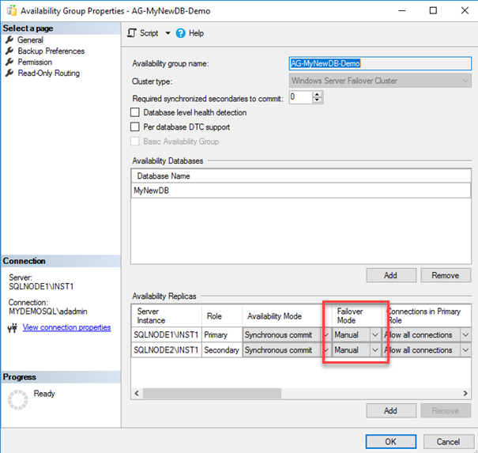

* **Run this command to check if the SQL service is running:**

$server = $env:computername

$object = Get-service -ComputerName $server | where {($_.displayname -like "SQL Server (*") }

if ($object){

$instDetails= $object |select DisplayName,Status

$instDetails

}else{

Write-Host "0 SQL Server instances discovered"

}



* **Run this command to check the current Primary role:**

$instanceName = "server\database"

$AGName = "AvailabilityGroupName"

#Test availability replica health

$AGReplicaPath = "SLSERVER:\SQL\$($instanceName)\AvailabilityGroups\$($AGName)\AvailabilityReplicas"

Get-ChildItem $AGReplicaPath |Format-Table -AutoSize #-Path $AGReplicaPath

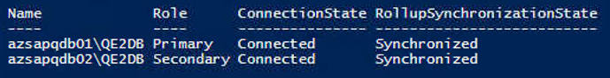

* **Now run this command to check the current Failover Mode:**

$instanceName = "azsapqdb02\QE2DB"

$query = "USE master

GO

SELECT

replica_server_name as Nodes,

availability_mode_desc as AvailabilityMode,

failover_mode_desc as FailoverMode

FROM sys.availability_replicas"

Invoke-Sqlcmd -ServerInstance $instanceName -Query $query

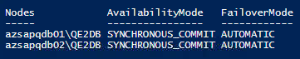

* **Once validated, run this command to change Failover Mode from Automatic to Manual**

$instanceName = "server\instancename"

$query = "USE [master]

GO

ALTER AVAILABILITY GROUP [SAPQE2AG]

MODIFY REPLICA ON N'azsapqdb01\QE2DB' WITH (FAILOVER_MODE = MANUAL)

GO

USE [master]

GO

ALTER AVAILABILITY GROUP [SAPQE2AG]

MODIFY REPLICA ON N'azsapqdb02\QE2DB' WITH (FAILOVER_MODE = MANUAL)

GO"

Invoke-Sqlcmd -ServerInstance $instanceName -Query $query

* **Validate again the Failover mode by executing this command:**

$instanceName = "azsapqdb02\QE2DB"

$query = "USE master

GO

SELECT

replica_server_name as Nodes,

availability_mode_desc as AvailabilityMode,

failover_mode_desc as FailoverMode

FROM sys.availability_replicas"

Invoke-Sqlcmd -ServerInstance $instanceName -Query $query

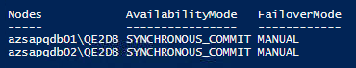

1. **Connect to the secondary replica and Suspend data movement for the secondary replica databases so that the primary replica does not send any transaction block to the specific secondary replica. If you suspend the data movement from the primary replica, it suspends data movement for all secondary replicas. Therefore, you should do it from the secondary replica in which you are applying the SQL Server Patches**

$instanceName = "server\database"

$AGName = "AvailabilityGroupName"

$AvailabilityDB = "SQLSERVER:\Sql\Server\Instance\AvailabilityGroups\$AGName\AvailabilityDatabases”

Get-ChildItem $ AGName | Suspend-SqlAvailabilityDatabase

#Suspend or Resume

1. **Connect to the VM of the secondary replica and apply the service pack\cumulative pack as required. The installation service pack or cumulative pack is straightforward. You can follow the installation wizard and apply the latest patch.**

$sqlpatch = “D:\<package_name>.exe”

& $sqlpatch /qs /IAcceptSQLServerLicenseTerms /Action=Patch /AllInstances

1. **Restart the secondary replica. You must restart the server after applying the latest patches**

Restart-Computer -Force

1. **Once the secondary replica comes online, perform validation by using the PS commands below:**
   * **Verify SQL Services are online:**

$server = $env:computername

$object = Get-service -ComputerName $server | where {($_.displayname -like "SQL Server (*") }

if ($object){

$instDetails= $object |select DisplayName,Status

$instDetails

}else{

Write-Host "0 SQL Server instances discovered"

}



* + **SQL Server version validation**

Invoke-Sqlcmd -Query "SELECT @@VERSION;" -ServerInstance " server\instancename" |Format-List

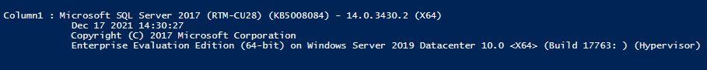

* + **Databases validations**

####Check SQL Server Database Status####

$instanceName = "server\instancename "

$query = "SELECT name as DBName, state_desc as Database_status FROM sys.databases"

Invoke-Sqlcmd -ServerInstance $instanceName -Query $query |Format-Table

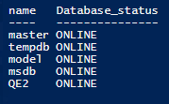

1. **Now, resume data movement from the secondary replica database. The secondary replica might take time to come in the synchronized state because it applies all pending transaction blocks on the secondary database before changing status to synchronize. Wait for the AG dashboard to become healthy.**

$instanceName = "server\instancename "

$AGName = "AvailabilityGroupName"

$AvailabilityDB = "SQLSERVER:\Sql\Server\Instance\AvailabilityGroups\$AGName\AvailabilityDatabases”

Get-ChildItem $ AGName | Resume-SqlAvailabilityDatabase

#Suspend or Resume

* + **Validate Availability Connection and Health State**

#Import-Module SQLPS -DisableNameChecking

$instanceName = "server\ instancename "

$AGName = "AvailabilityGroupName"

####Test availability replica health####

$AGReplicaPath = "SQLSERVER:\SQL\$($instanceName)\AvailabilityGroups\$($AGName)\AvailabilityReplicas"

Get-ChildItem $AGReplicaPath |Format-Table -AutoSize #-Path $AGReplicaPath

####Test availability database replica state health####

$AGReplicaStatePath = "SQLSERVER:\SQL\$($instanceName)\AvailabilityGroups\$($AGName)\DatabaseReplicaStates"

Get-ChildItem $AGReplicaStatePath | Test-SqlDatabaseReplicaState

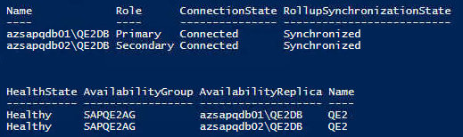

1. **Once it is on Healthy state, perform a manual failover from the current primary replica to the secondary replica in the primary site:**

$instanceName = "server\ instancename" #in this case, *azsapqdb02\QE2DB*

$AGName = "AvailabilityGroupName"

$AGPath = “SQLSERVER:\Sql\$($InstanceName)\AvailabilityGroups\$AGName”

Switch-SqlAvailabilityGroup -Path $AGPath -Force

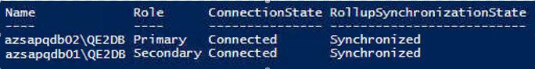

1. **After the failover, the current primary replica changes its state to a secondary replica. We can similarly apply the SQL Server patches by following steps 2 to 6**
2. **Once the new secondary replica is also patched, and validations are done, perform an AG failback. After the failover, availability group primary replica is the same before and after failover as well**

$instanceName = "server\ instancename" #in this case, *azsapqdb01\QE2DB*

$AGName = "AvailabilityGroupName"

$AGPath = “SQLSERVER:\Sql\$($InstanceName)\AvailabilityGroups\$AGName”

Switch-SqlAvailabilityGroup -Path $AGPath -Force

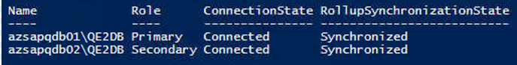

1. **Change the failover mode to automatic for the primary and secondary replica in the synchronous data commit mode:**

$instanceName = "server\instancename"

$query = "USE [master]

GO

ALTER AVAILABILITY GROUP [SAPQE2AG]

MODIFY REPLICA ON N'azsapqdb01\QE2DB' WITH (FAILOVER_MODE = AUTOMATIC)

GO

USE [master]

GO

ALTER AVAILABILITY GROUP [SAPQE2AG]

MODIFY REPLICA ON N'azsapqdb02\QE2DB' WITH (FAILOVER_MODE = AUTOMATIC)

GO"

Invoke-Sqlcmd -ServerInstance $instanceName -Query $query

* **Validate the Failover mode by executing this command:**

$instanceName = "server\instancename"

$query = "USE master

GO

SELECT

replica_server_name as Nodes,

availability_mode_desc as AvailabilityMode,

failover_mode_desc as FailoverMode

FROM sys.availability_replicas"

Invoke-Sqlcmd -ServerInstance $instanceName -Query $query



1. **To this point, SQL Server pathing is complete. It is also recommended to perform a database consistency checker (DBCC CHECKDB) after applying the patches**

* **Connect to the primary node and run this command:**

$instanceName = "server\instancename"

$query = "DBCC CHECKDB (N'Instancename') with all_errormsgs,no_infomsgs"

Invoke-Sqlcmd -ServerInstance $instanceName -Query $query

1. **The DR replica node is in asynchronous mode for SQL Server Always On Availability Group; therefore, it is already set to manual failover. Do the following steps**
   1. **Pause the data movement from the DR replica node**
   2. **Apply patch on the DR replica**
   3. **Perform the database and SQL validation**
   4. **Resume data movement**